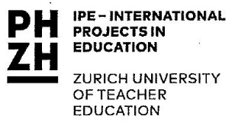
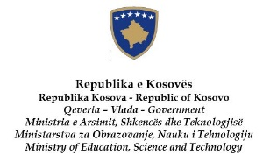
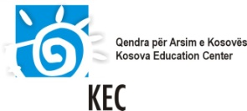

The Kosova Academy for Democracy and Human Rights

in cooperation
with the Kosova Education Center; the Ministry of Education, Science and Technology of Kosovo; the European Wergeland Centre and the Centre IPE of Zurich University of Teacher Education

Kosovo
6 – 10 December 2016

SELECTION CRITERIA FOR SCHOOL TEAMS

Team selection:
Information provided via the application form.

- Full team applying:
  - a school head (or deputy head)
  - a teacher
  - a parent representative or a NGO representative
- School is from Kosovo
- Schools of all levels of pre-university education
- Team members are in a position to act as multipliers for EDC/HRE
- Address vulnerable groups in their work
- High motivation for participation
- Concrete ideas for implementation and dissemination (related to EDC/HRE, target groups, duration, multiplying effect, cooperation/partners)

Group composition:
- Eleven teams represented
- Gender, geographical, language balance
- Different levels of knowledge about and experience with EDC/HRE

