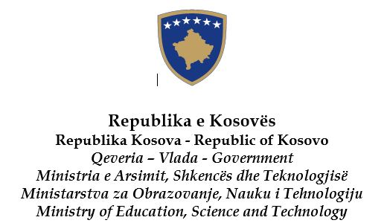
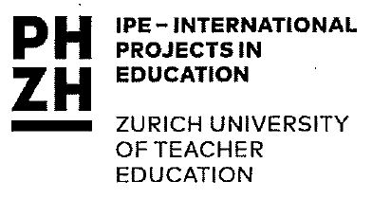
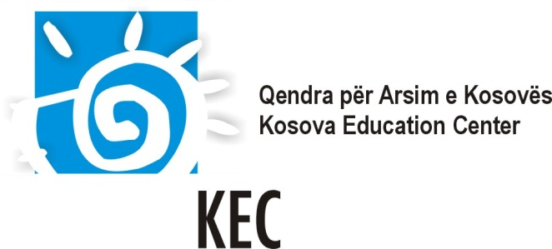

The Kosova Academy for Democracy and Human Rights

in cooperation
with the Kosova Education Center; the Ministry of Education, Science and Technology of Kosovo; the European Wergeland Centre and the Centre IPE of Zurich University of Teacher Education

Kosovo
6 – 10 December 2016

Background:
Democratic societies and peace can only be built by democratic citizens. Today as never before the sustainability of many democracies in Europe is at stake challenged by ongoing conflicts and violence, racism, discrimination, xenophobia and corruption. Education can be a very powerful tool to deal with these challenges. In fact, it plays a crucial role in promoting respect for human rights, democracy and the rule of law, and in preparing young people for an active life in democratic societies.

Schools have a great potential to provide a place where young people are encouraged to learn and practice democracy and human rights. But how to develop a democratic school culture which can build the backbone for democratic socities?

The CoE Charter on Education for Democratic Citizenship and Human Rights Education, adopted by Recommendation CM/Rec(2010), underlines EDC/ HRE as a primary way of “equipping learners with knowledge, skills and understanding and developing their attitudes and behaviour” so that they promote and protect human rights and fundamental freedoms. Besides teachers, who obviously play a vital role here, the Charter acknowledges the role of other stakeholders in education and in the community to join efforts towards creating democratic institutions.

As for Kosovo, the New Kosovo Curriculum Framework is competences-based with one of them being citizenship competence. There is a strong need to introduce active learning methods and democratic values that lead to equping students with knowledge, skills and attitudes necessary for coexistence in diverse society.

About the Kosovo Academy
The Kosovo Academy is a training course on Education for Democratic Citizenship and Human Rights Education, organised jointly by the Kosova Education Center (KEC), the Ministry of Education, Science and Technology (MEST), the Zurich University of Teacher Education (PHZH) and the European Wergeland Centre (EWC). The Kosova Academy 2016 is additionally supported through a contribution of the centre IPE at Zurich University of Teacher Education as an implementation project of the Albanian Network Project ‘NEZI’ (https://phzh.ch/en/IPE/Projects/Transnational-Projects/First--Second--and-Inter-cultural-Networks/).

The Academy builds on the Council of Europe programme: Learning Democray and Human Rights, financed via a voluntary contribution from Norway, and it promotes a whole-school approach to education for democratic citizenship and human rights.

The Academy also builds on the CoE work in Kosovo through projects such as the Interculturalism and Bologna Process (IBP), Promoting Cultural Diversity in Kosovo (PCDK), and Increasing Access to Education and Intercultural Understanding (ACCESS). Within the framework of these projects, key EDC/HRE teaching materials of the Council of Europe were translated (until 2011) and other materials were developed and accredited with Ministry of Education, Science and Technology. In addition, within the project Living Democracy, six teaching books about EDC/HRE were developed. These books have been translated in local languages in Kosovo and are available online. These materials will be used during the training and put into practice in participating schools.

Aims and objectives:
The Academy aims to strengthen a democratic culture in schools in Kosovo through the training of educational professionals and community actors, and by developing further their capacity to teach, implement and promote EDC/HRE in their schools and communities.
More specifically the Academy will:
- Facilitate sharing of experiences and good practices in EDC/ HRE
- Support participants in developing and implementing a school-based project
- Encourage cooperation and partnership among different actors involved in education and between the participating schools
- Support the development of a network of multipliers promoting EDC/ HRE
- Facilitate the implementation of the CoE Charter for EDC/ HRE and the use of CoE materials at local level

General approach:
The training follows a whole-school approach to EDC/HRE and addresses different spheres of school life: learning and teaching processes/curriculum, school governance and community involvement and partnership. This approach encourages the active participation of all stakeholders of school life in building an environment where principles of human rights and democracy can be learned and practiced.
The training will be based on the following CoE tool and materials:
- Council of Europe Charter on Education for Democratic Citizenship and Human Rights
- Democratic Governance of Schools
- How all teachers can support citizenship education: a framework for the development of competences
- Living Democracy manuals
- The Living Democracy Website (www.living-democracy)
- Compass – A manual for Human Rights Education with Young People
- Compasito – manual for Human Rights Education with children
Outline of the Academy:
The Kosovo Academy is composed of the following 2 phases:
Phase 1: A five-day training seminar (6 – 10 December 2016)
The seminar is the core of the Academy. The trainers and participants work face-to-face together, and share their experiences with EDC/HRE. Participants analyze the current situation in their school and community and reflect on their practice in view of EDC/HRE principles. Based on this analysis, and supported by trainers, each team develops a school-based project directed towards fostering a democratic culture.
Phase 2: Follow-up phase (January – May 2017)
This phase supports participants in implementing their school-based projects. Throughout this phase, trainers provide ongoing support to all teams. Also, a follow-up face-to-face meeting will be organized sometime in February or March 2017 to discuss the progress of the school projects, the ongoing collaboration, and to plan the evaluation activities.

Target groups and profile of participants:
Participants are invited to join the Academy as a team of three members. Each team consists of two representatives from the same school, including the school head and a teacher, together with one representative of a parent association or an NGO that already cooperates with the school or wishes to do so.
The Academy is available for teams from schools all over Kosovo.

Working languages:
The training will be run in Albanian, English and Serbian (depending on participants’ needs).

Trainers/experts:
The training will be run by a very experienced team of local and international trainers/experts.

Venue:
Kosovo, hotel “Sharri” Prevallë
Costs:
Travel costs, accommodation, meals and all activities included in the training program are covered or will be reimbursed by the organizers.
Application and selection procedure:
Application should be made as a team. Please find the application form and the selection criteria. Applications must be submitted online by 30 September 2016 to: mmula@kec-ks.org.
KEC and MEST will select 11 teams (33 participants) on the basis of their profile. The selection will take into account balance between, sexes, EDC/ HRE experiences, motivation and ideas for dissemination. Only teams who will be selected will be informed about their participation by 14 October 2016.
Certificate of attendance
Upon completion of the Academy all participants will receive a certificate of attendance.

Other information:
The success of the training activities depend on the commitment of all the participants. By accepting to participate in the Academy, participants agree to participate actively in all phases of the training.

Contact:

Kosova Education Center (KEC):
Contact person: Ms. Melinda Mula, Coordinator
Tel: +377 44 198 866
E-mail: mmula@kec-ks.org
Website: www.kec-ks.org

