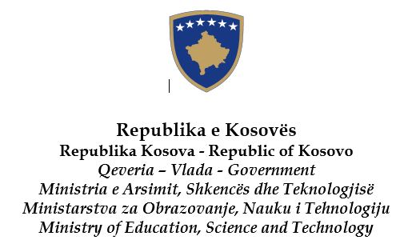
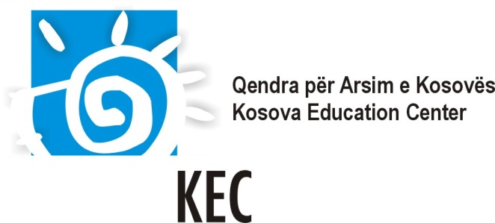

The Kosova Academy for Democracy and Human Rights

in cooperation
with the Kosova Education Center; the Ministry of Education, Science and Technology of Kosovo; the European Wergeland Centre and the Centre IPE of Zurich University of Teacher Education

Kosovo
6 – 10 December 2016

SCHOOL TEAM APPLICATION FORM

Please submit this application form by 30 September 2016, by e-mail to:
Ms. Melinda Mula: mmula@kec-ks.org

If selected, the nominated team will receive an invitation e-mail and further information by 14 October 2016 from the organizers.
It will be sent to the CONTACT e-mail address provided in the application.

School of Applicant Team: |  | Team Leader  Full name: ………..………………………………  Tel: ………………………………………………  CONTACT e-mail: ..............................................  (all replies regarding the application will be sent to this address)

Information about the team
(Please note that we only accept full teams)

1. School Head (or deputy head): Mr Ms Year of birth: .................

Surname :.....................................................................First Name :
E-mail: …………………………………………………..
Academic background: ……………………………………………………….………………………………
……………………………………………………………………………………………………..…………
Years of experience as a school head: …………………………………………………………..….….……

2. Teacher: Mr . Ms Year of birth: ......................

Surname:………………............................................First Name:
E-mail: …………………………………………………..
Academic background: ………………………………………………………………………………………
………………………………………………………………………………………………………..………
Teacher of (subject): .................................................Years of experience as a teacher: ……........................

3. NGO or parents’ representative (please underline which is relevant):
Mr. Ms. Year of birth: …………….

Surname: ………………………………………… First Name: …………………………………………….
E-mail: …………………………………………………
Academic background: ……………………………………………………………………………………… ……………………………………………………………………………………………………………….
Current position: …………………………………………………………………………………………….

Information about the school

School Name:........................................................................................................................................................

Address :

Tel. :....................………… Fax : ...…..……………….……E-mail :...............................................................

Age range of pupils: from: ……………….…... to: ….…….....….............

Type of school: ...................................................................................................................................................

I. Please describe your motivation to participate in the Academy:

II. Please describe your ideas for implementation and dissemination upon returning to your school and
community:

III. Working languages

The training will be available in Albanian, Serbian and English (depending on participants needs). Group work is foreseen and it will be supported in local languages. Sessions held in English will be translated.

Training materials and hand-outs will be provided in the languages mentioned above. Also, additional materials in English will be provided. Thus, it would be desirable if at least one member of the team has a good knowledge of English.

IV. In order to tailor the training program to your needs we would like you to reflect on the situation in your school:

Vision:
What school culture you want to promote in your school through your participation in the Academy?
…………………………………………………………………………………………………………….

Experiences:
What has your school done/ how has your school worked in relation to the topics covered by the Academy?
……………………………………………………………………………………………………………

Challenges:
What type of challenges/ daily problems makes the Academy training relevant to your school?
……………………………………………………………………………………………………………

Date: ...………………………………………….........

Signature of school head: ....…………...….…............

Signature of teacher: ....…………………..…….........

Signature of parent/partner organization: ....……………............

