USAID’s “After School Support for Teens” Program (ASSET) is a 5 year USAID program, managed by Kosova Education Centre (KEC), in partnership with FHI 360 and Crimson Capital Corp. ASSET’s main aim is to develop employability and entrepreneurial skills in Youth and a positive attitude to their future.

ASSET’s slogan is: “Preparing Kosovo Youth for 21st Century Life and Work.” Its activities include:

1: Developing Life & Work Competences

ASSET supports the implementation of Kosovo’s Curriculum Framework and Core Curriculum for Grades 10-12, in particularly by providing support relating to the area of “Life and Work” which involves: career counselling and orientation; technology including ICT, and work and entrepreneurial education. To help schools to implement practical project work, ASSET will assist them to establish “Career and Enterprise Hubs”. These resource centers will include “Makerspaces”, for use during and after school hours.

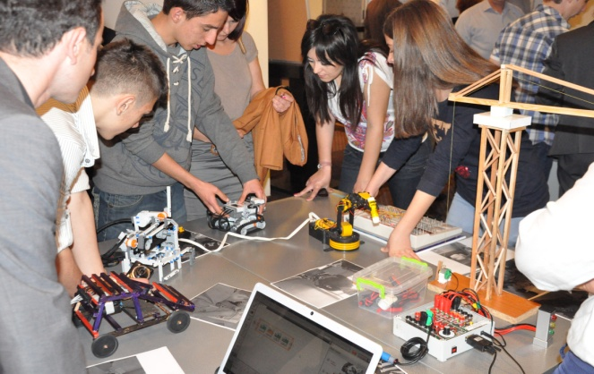

A Makerspace is a collaborative workspace, where students can participate in practical creative projects aimed at developing entrepreneurial attitudes and employability competences. They use a variety of technology and materials, in practical creative projects, relating to science, technology, engineering, mathematics, art and music. They create solutions, design and make products, explore their own creative interests, and develop key competences and self-confidence.

2: Supporting Careers and Entrepreneurial Education in Schools

ASSET aims to assist the Ministry of Education and schools to implement its careers and entrepreneurial education curriculum for Grades 10-12. This will involve developing: assessment tools for curriculum learning outcomes; an accredited teacher training course; teaching materials and resources; training teachers; and working with partners to enhance a “Virtual Careers Center”, an online careers portal available to all young people and their parents both in and outside of school.

3: Connecting Schools with Employers and the Community
With its partners, ASSET aims to engage with businesses and entrepreneurs interested in supporting the development of workforce-related skills in students through projects and work experience. ASSET’s “Adopt an Asset” activity aims to enable businesses inside and outside Kosovo to support individual students by providing work experience, internships, careers advice, and mentorship.

ASSET’s Community Youth Mapping activity will engage young people and adults in identifying community-based resources, needs, and opportunities. Youth mapping is an action-oriented activity where teens research their communities, taking surveys, and inputting and reflecting on the data. Involving youth in these activities provides them with skills that enable them to become agents of change and productive contributors within their communities.

